**COA Laboratory**

**Steps for installation and execution of 8086 practical laboratory based programs**

1. For Windows Operating System, first we need to have DOS prompt, if not in your machine go to website, <https://www.dosbox.com/download.php?main=1> and on homepage you have a green color button named Download Now click on it, and on your machine location download the file(preferably at C drive).
2. Now, for tasm installation, zip file is provided with document, download the zip file and unzip it at location C:\TASM folder.
3. Shortcuts will be created at desktop for dos and tasm.
4. Double click on tasm icon and you will get prompt, C:\TASM
5. DOS prompt will be opened, there type a command to write your program as C:\TASM\edit

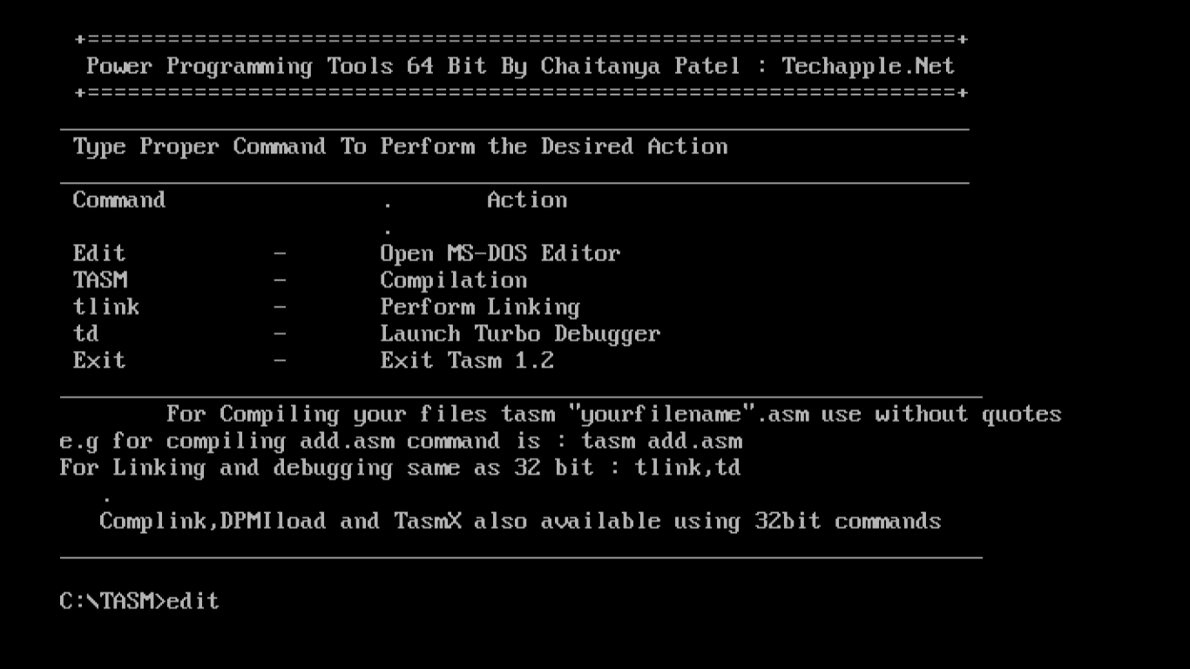

1. Enter the sample program as provided to display a message

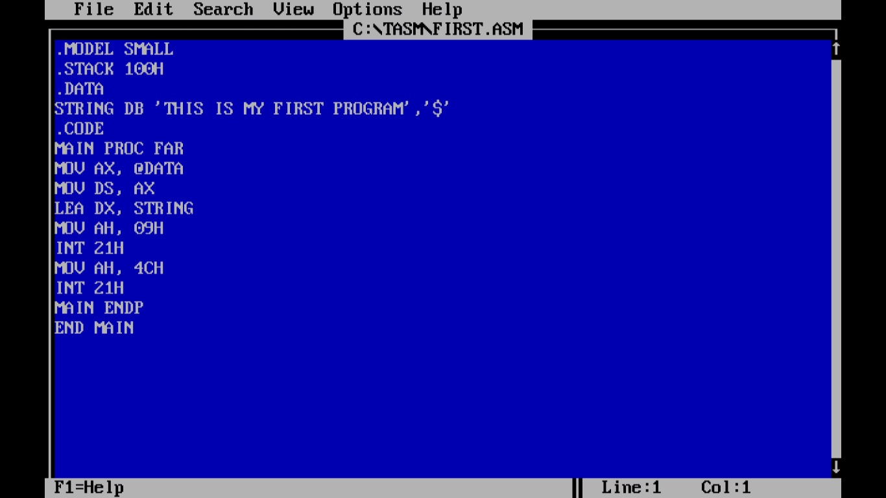

1. **Save program as first.asm** at location C:\TASM
2. For compilation and execution of program, Click on File and then click on exit, you come at DOS prompt C:\Tasm
3. Now give commands as below:

**TASM first.asm**

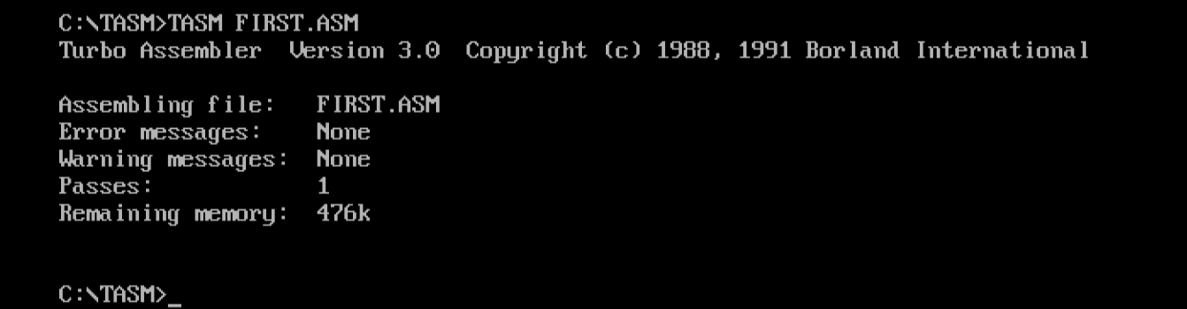

**TLINK first.obj**

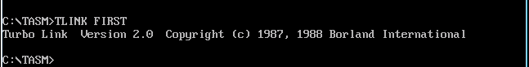

**first.exe**

